Student Performance Prediction System

Project Id: PY-PT57

Name : Paras Goel(Team Leader)
Class Roll Number:57
University Roll Number :2028790
Section and Group: P (G2)

Name : Pratyaya Amrit Raj
Class Roll Number:58
University Roll Number : 2028805
Section and Group: : P (G2)

Name : Ujjwal Singh Rohilla
Class Roll Number:76
University Roll Number : 2028894
Section and Group: : P (G2)

- Problem Description 3
- Architecture 4
- Models model 5
- Evaluation metrics used 6
- Preliminary Results and Visualizations 7
- References 8

- Problem Description
In today’s world, early detection of diseases plays a very important role in improving healthcare outcomes. Many diseases can be prevented or controlled if identified at an early stage. However, manual analysis of patient data is time-consuming and may lead to errors.
The objective of this project is to develop a machine learning-based system that can predict whether a person is likely to have a disease based on various health parameters. These parameters include age, gender, body mass index (BMI), blood pressure, glucose level, cholesterol level, smoking habits, physical activity, and family history.
In Phase 2 of this project, the main focus is on data preprocessing, which is a crucial step before applying any machine learning model. Raw data collected from real-world sources often contains inconsistencies, missing values, and unnecessary information. Therefore, preprocessing is required to clean and prepare the dataset so that it can be effectively used for model training in the next phase.

- Architecture

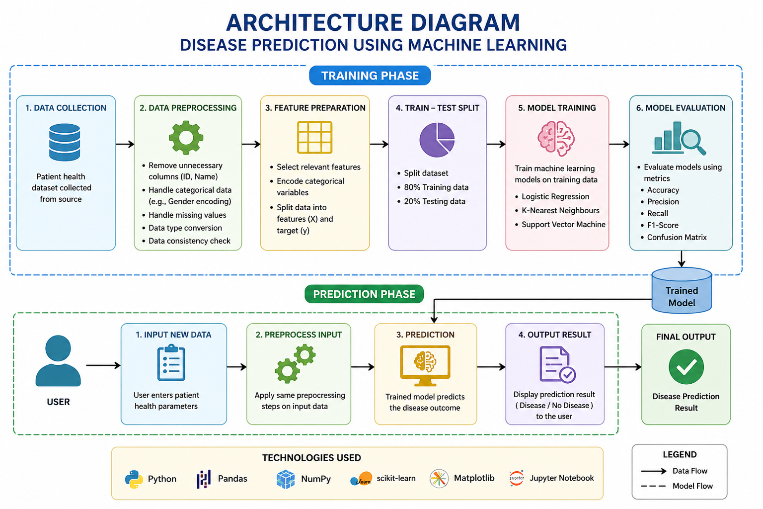

The following preprocessing steps were performed:
- Removed unnecessary columns such as Patient_ID and Name
- Handled categorical data:
  - Converted Gender into numerical form (Male = 1, Female = 0)
- Checked for missing values and ensured dataset completeness
- Ensured all features are in numeric format for model training
- Verified consistency and correctness of data
These steps helped in preparing a clean and structured dataset suitable for machine learning models

- Models Used(Applied/ Planned) Give a brief introduction of the models used

The following models are planned to be implemented in the next phase:
- Logistic Regression
- K-Nearest Neighbours (KNN)
- Support Vector Machine (SVM)
These models will be used to classify whether a patient has a disease or not.

- Logistic Regression
Logistic Regression is a supervised machine learning algorithm used for classification problems. It is mainly used when the output is binary, such as predicting whether a patient has a disease (1) or not (0). It works by calculating the probability of an outcome using a mathematical function called the sigmoid function. Based on this probability, it classifies the data into different categories. It is simple, fast, and easy to interpret.

- K-Nearest Neighbours (KNN)
K-Nearest Neighbours (KNN) is a simple and intuitive machine learning algorithm used for classification and regression. It works by finding the “K” closest data points (neighbors) to a given input and assigning the class based on majority voting. For example, if most of the nearest neighbors have a disease, then the new data point is also classified as having a disease. It does not require training like other models and is easy to understand.

- Support Vector Machine (SVM)
Support Vector Machine (SVM) is a powerful supervised learning algorithm used for classification and regression tasks. It works by finding the best boundary (called a hyperplane) that separates data into different classes. SVM tries to maximize the distance between different classes to improve accuracy. It is effective in high-dimensional data and works well for complex datasets.
- Evaluation metrics used

The performance of models will be evaluated using:
- Accuracy
- Precision
- Recall
- F1 Score
- Confusion Matrix

- Accuracy
Accuracy is the ratio of correctly predicted values to the total number of predictions. It tells how often the model is correct.
Formula:
Accuracy = (Correct Predictions) / (Total Predictions

- Precision
Precision measures how many of the predicted positive cases are actually correct. It focuses on the quality of positive predictions.
Formula:
Precision = TP / (TP + FP)

- Recall
Recall measures how many actual positive cases are correctly identified by the model. It focuses on finding all positive cases.
Formula:
Recall = TP / (TP + FN)

- F1 Score
F1 Score is the balance between Precision and Recall. It is useful when the dataset is imbalanced
Formula:
F1 Score = 2 × (Precision × Recall) / (Precision + Recall)

- Confusion Matrix
A confusion matrix is a table used to evaluate model performance. It shows the number of correct and incorrect predictions.

 | Predicted Positive | Predicted Negative
Actual Positive | True Positive (TP) | False Negative (FN)
Actual Negative | False Positive (FP) | True Negative (TN)

5. Preliminary Results and Visualizations

In this phase, basic data understanding was performed:

- Dataset preview using .head()
- Checked distribution of target variable (Disease)
- Identified imbalance in dataset (more disease cases than non-disease)

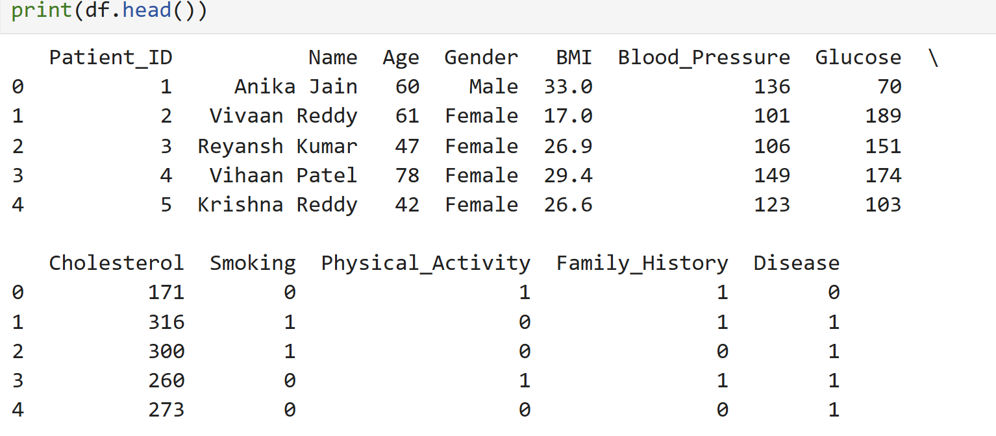

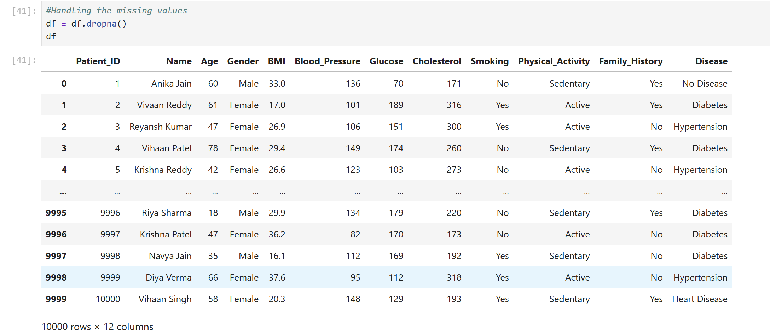

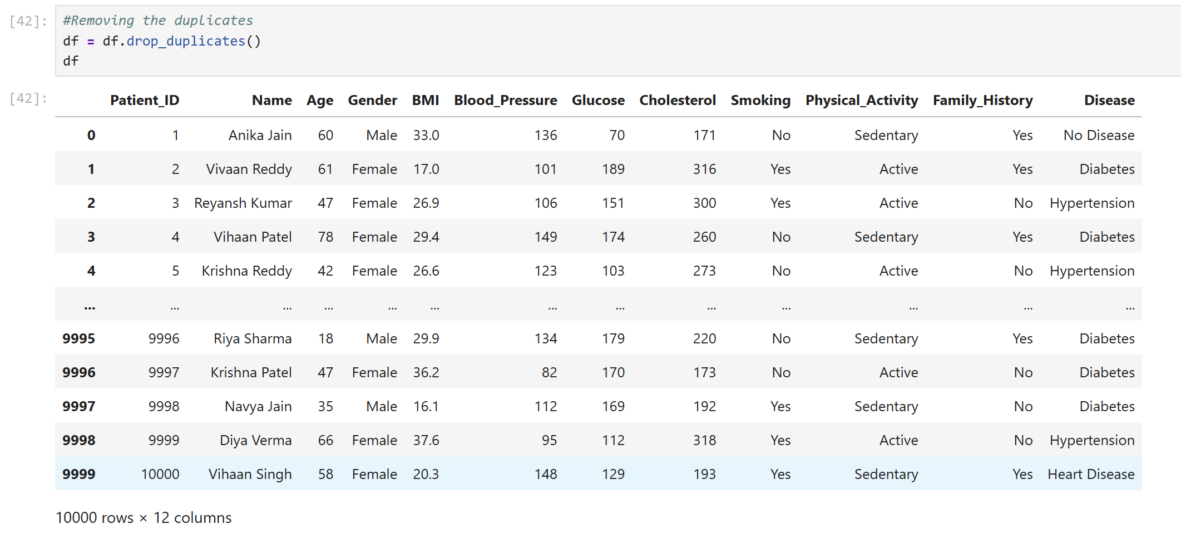
6. References:
Books:
- Let Us Python – Yashavant Kanetkar

Online Resources:
  - GeeksforGeeks – https://www.geeksforgeeks.org/
  - TutorialsPoint – https://www.tutorialspoint.com/cprogramming/index.htm
  - Stack Overflow – https://stackoverflow.com

